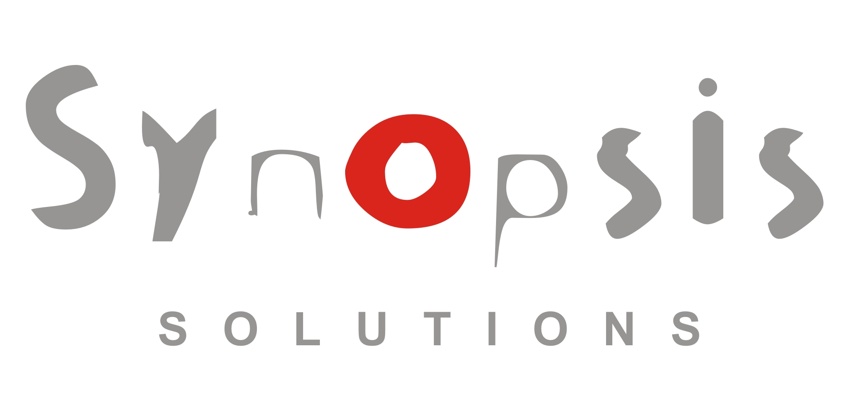

Client Website Planner

This website planner will help you form the foundation of your website strategy. The time you spend now - completing this form will save you time and money later. It also benefits us by giving us an accurate assessment of your needs. Complete as much of this form as you can and return it as an email attachment to info@synopsis-solutions.com

The easiest way to fill out this form is to use the TAB key to move from one field to the next.

Contact Details

Contact Name: Name
Job Title: Title
Company or Organisation Name: Organisation/Company
Address: Address

Phone Number: Phone
Mobile: Mobile
Email: Email
Existing Website (if any): http://www.yoursite.com

1. Domain Name and Web Hosting

Have you already registered a domain name? Yes No
If “Yes”, what is your existing domain name? Domain Name
If “No”, and if there is no sense of urgency to register a domain name, please wait to learn more about the importance of choosing the right domain name for your needs before paying good money on a domain that may be less fruitful.
Would you like help registering a domain name? Yes No
If yes, what name are you considering? Domain Name
Do you have your own web hosting? Yes No
Would you like us to help arrange web hosting for you? Yes No

2. Purpose and Audience

What is the main purpose of your website? Example: “Market Products/Services Online” “Create an online presence for an existing company” etc., Purpose

Who is your target audience? Audience

3. What do you want the website to be?

Describe how you want the website to come cross to people viewing it? How should they be feeling when viewing it and what kind of image you want them to get from the website. The Site should be ..

4. Projected Site Size

We specialise in building websites that best fit your business needs and we will offer advice on how best to achieve your goals. Until that time you can help us to develop a more accurate cost estimate if you could categorize your web project into one of the layouts that follow.

Choose a description from the list that best describes the layout of your website?

 | 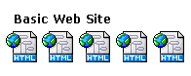 | Basic website with 5-10 pages
 | 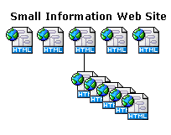 | Small website with 10-20 pages  (some subsections to navigation)
 | 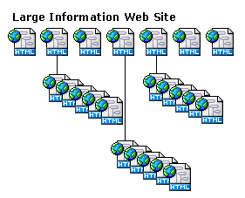 | Information website with many pages  (several subsections to navigation)

5. Site Features

Choose the features you would like included in your website beyond basic products/services and informational pages:

Site Map
News Section
Photo Gallery
Flash Animation
Online Contact Forms
Website Statistics Tracking
Splash Page
Edited Video
Music Player
RSS Feeds
Interactive Menu

6. Site Organisation (Navigation)

Describe the main navigation labels for links to your pages; examples: About Us, Services, etc.

Home | Page 2 | Page 3 | Page 4 | Page 5 | Page 6 | Page 7
Page 8 | Page 9 | Page 10 | Page 11 | Page 12 | Page 13 | Contact Us

7. Content

How much help can you provide (For those who have built a website before)
We will provide all logos, documents, images and text ready for web
We have a full idea of the website sitemap and number of pages required
We would like to assets in the building of the website and provide support
We will need Synopsis Solutions to deliver the whole website from start to finish
We will need total support throughout the build, but will provide support if we can

Who will provide the logo for your website? (Choose appropriate)
I have a digital company logo in ‘EPS’ or ‘JPEG’ format.
I only have my logo on print and do not have digital copy.
I don’t need a logo
I would like Synopsis Solutions to design a logo

Who will provide the images for your site?
I have all images web ready in ‘GIF’ or ‘JPEG’ format.
I have all images chosen but need to be optimised for the web.
I would like Synopsis Solutions to photograph our location/ or select images for us.
I would like Synopsis Solutions to create custom graphics and/or images for my site.

Who will provide the copy/text for your site?
I have the entire content (text) ready in a word document format for each page in the site.
I have the content (text) ready, but I would like Synopsis Solutions to edit/optimise it for the
web.
I would like Synopsis Solutions to write the content for me.

8. Web Design Elements

This part of the profile is very important. If time allows it would be good for you to do a search on the internet to find sites of similar interest to your vision for your project. This will help us better understand your preferences in colour scheme and layout. Rest assured your site will be custom designed and original from start to finish.
List two of your competitor’s sites
put web address here
put web address here
List sites that represent your ‘taste’ in colour, layout and overall appeal
put web address here
put web address here
put web address here

9. Desired Keywords

The words and phrases searchers type into the search engines are called keywords. Please enter the top ten keywords you believe searchers might use to find your website. Synopsis Solutions provides detailed keyword research to his clients based on the desired keywords and making keyword suggestions based upon his findings.

keyword | keyword
keyword | keyword
keyword | keyword
keyword | keyword
keyword | keyword

10. Budget and Timeframe

What is your budget for your website design and development? £ 0.00

What is the desired turnaround time for your project?
Please note; At Synopsis Solutions we aim to finish all website projects within 3 months of the start date. All this depends on the complexity and project elements, most websites on average take no more than 1 month to complete. We will go through with you the time scale and budget required for your project before we start.

11. Maintenance and Updates

After completing the site do you want Synopsis Solutions to perform ongoing maintenance and updates to the content?
Yes No Not Sure

If not who will maintain your site after it goes online?

Please Note: Even if you desire to maintain the site yourself or in the unlikely event of a separation and/or termination of services and you should desire to hire a third party to maintain the site Synopsis Solutions retains Copyright credit for all custom graphics, logos, design elements and SEO elements created on all pages.

Thank you for taking the time to complete this website planner. We will contact you
as soon as possible after you receiving your form. Please make sure you email it to
info@synopsis-solutions.com

